RAINFORD CHURCH OF ENGLAND PRIMARY SCHOOL

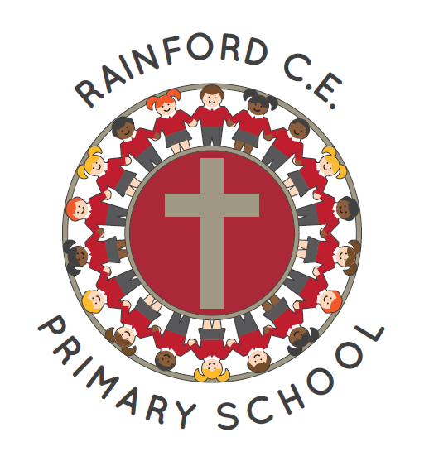

‘Learning and growing together to achieve our best in the love of God’
EYFS Policy

For Approval by S& Q Committee: November 2022

To be reviewed on or before:

Signed…………………………………………… Chair of S&Q

Signed…………………………………………… Headteacher

Our Mission Statement
‘Learning and growing together to achieve our best in the Love of God’

School Aims

In order to prepare today’s children for tomorrow’s challenges, Rainford CE Primary Schools aims to achieve the following:

Every child will be encouraged to understand the meaning and significance of faith, experience God’s love and develop the spirituality to enable them to live out our Christian values of love, joy, peace, friendship, forgiveness, perseverance and justice

Every child will achieve their full potential through being a highly motivated, resilient and independent learner who embraces new experiences, has confidence to tackle challenges and go onto develop a lifelong love of learning.

Every child will value themselves as a unique individual with special qualities and strengths developing self-discipline and honesty; taking responsibility for their own actions and appreciating their ability to make a positive difference in the world.

Every child will appreciate and respect others, celebrate differences between individuals and groups and respect and care for God’s creation and the environment.

Every child will be encouraged to make healthy choices and appreciate the benefits of a healthy lifestyle.
In order to do this, we will constantly reflect the Christian ethos of our school in our relationships with our children, their families, our staff, the church and the wider community.

Content
- EYFS Policy Aims
- Legislation
- Curriculum

- EYFS Policy Aims

At Rainford C E School, we want children to enjoy their first years at school and in our EYFS we provide a safe, caring environment where children can learn and grow in all areas of their development. Our pre-school, Raindrops, and Reception use the statutory Early Years Foundation Stage and the non-statutory educational program, Development Matters 2021, as the basis of their curriculum
• That children access a broad and balanced curriculum that gives them the broad range of knowledge and skills needed for good progress through school and life
• Quality and consistency in teaching and learning so that every child makes good progress and no child gets left behind
• A close working partnership between staff and parents and/or carers
• Every child is included and supported through equality of opportunity and anti-discriminatory practice

- Legislation

This policy is based on requirements set out in the statutory framework for the Early Years Foundation Stage (EYFS) that applies from September 2021.

- Curriculum

Our early years setting follows the curriculum as outlined in the latest version of the EYFS statutory framework that applies from September 2021. The EYFS framework includes 7 areas of learning and development that are equally important and inter-connected. However, three areas known as the prime areas are seen as particularly important for igniting curiosity and enthusiasm for learning, and for building children’s capacity to learn, form relationships and thrive.

The prime areas are:

- Communication and language
- Physical development
- Personal, Social and Emotional Development

These prime areas are then strengthened and applied through four specific areas:

- Literacy
- Mathematics
- Understanding the world
- Expressive arts and design

Our curriculum at Rainford C E involve activities and experiences for children, as set out under each of the areas of learning below.

Communication and Language

The development of children’s spoken language underpins all seven areas of learning and development. Children’s back-and-forth interactions from an early age form the foundations for language and cognitive development. The number and quality of the conversations they have with adults and peers throughout the day in a language-rich environment is crucial. By commenting on what children are interested in or doing and echoing back what they say with new vocabulary added, practitioners will build children's language effectively. Reading frequently to children, and engaging them actively in stories, non-fiction, rhymes and poems, and then providing them with extensive opportunities to use and embed new words in a range of contexts, will give children the opportunity to thrive. Through conversation, story-telling and role play, where children share their ideas with support and modelling from their teacher, and sensitive questioning that invites them to elaborate, children become comfortable using a rich range of vocabulary and language structures

Personal, Social and Emotional Development

Children’s personal, social and emotional development (PSED) is crucial for children to lead healthy and happy lives, and is fundamental to their cognitive development. Underpinning their personal development are the important attachments that shape their social world. Strong, warm and supportive relationships with adults enable children to learn how to understand their own feelings and those of others. Children should be supported to manage emotions, develop a positive sense of self, set themselves simple goals, have confidence in their own abilities, to persist and wait for what they want and direct attention as necessary. Through adult modelling and guidance, they will learn how to look after their bodies, including healthy eating, and manage personal needs independently. Through supported interaction with other children, they learn how to make good friendships, co-operate and resolve conflicts peaceably. These attributes will provide a secure platform from which children can achieve at school and in later life.

Physical Development

Physical activity is vital in children’s all-round development, enabling them to pursue happy, healthy and active lives7. Gross and fine motor experiences develop incrementally throughout early childhood, starting with sensory explorations and the development of a child’s strength, co-ordination and positional awareness through tummy time, crawling and play movement with both objects and adults. By creating games and providing opportunities for play both indoors and outdoors, adults can support children to develop their core strength, stability, balance, spatial awareness, co-ordination and agility. Gross motor skills provide the foundation for developing healthy bodies and social and emotional well-being. Fine motor control and precision helps with hand-eye co-ordination, which is later linked to early literacy. Repeated and varied opportunities to explore and play with small world activities, puzzles, arts and crafts and the practice of using small tools, with feedback and support from adults, allow children to develop proficiency, control and confidence.

Literacy

It is crucial for children to develop a life-long love of reading. Reading consists of two dimensions: language comprehension and word reading. Language comprehension (necessary for both reading and writing) starts from birth. It only develops when adults talk with children about the world around them and the books (stories and non-fiction) they read with them, and enjoy rhymes, poems and songs together. Skilled word reading, taught later, involves both the speedy working out of the pronunciation of unfamiliar printed words (decoding) and the speedy recognition of familiar printed words. Writing involves transcription (spelling and handwriting) and composition (articulating ideas and structuring them in speech, before writing).

Mathematics

Developing a strong grounding in number is essential so that all children develop the necessary building blocks to excel mathematically. Children should be able to count confidently, develop a deep understanding of the numbers to 10, the relationships between them and the patterns within those numbers. By providing frequent and varied opportunities to build and apply this understanding - such as using manipulatives, including small pebbles and tens frames for organising counting - children will develop a secure base of knowledge and vocabulary from which mastery of mathematics is built. In addition, it is important that the curriculum includes rich opportunities for children to develop their spatial reasoning skills across all areas of mathematics including shape, space and measures. It is important that children develop positive attitudes and interests in mathematics, look for patterns and relationships, spot connections, ‘have a go’, talk to adults and peers about what they notice and not be afraid to make mistakes.

Understanding the World

Understanding the world involves guiding children to make sense of their physical world and their community. The frequency and range of children’s personal experiences increases their knowledge and sense of the world around them – from visiting parks, libraries and museums to meeting important members of society such as police officers, nurses and firefighters. In addition, listening to a broad selection of stories, non-fiction, rhymes and poems will foster their understanding of our culturally, socially, technologically and ecologically diverse world. As well as building important knowledge, this extends their familiarity with words that support understanding across domains. Enriching and widening children’s vocabulary will support later reading comprehension.

Expressive Arts and Design

The development of children’s artistic and cultural awareness supports their imagination and creativity. It is important that children have regular opportunities to engage with the arts, enabling them to explore and play with a wide range of media and materials. The quality and variety of what children see, hear and participate in is crucial for developing their understanding, self-expression, vocabulary and ability to communicate through the arts. The frequency, repetition and depth of their experiences are fundamental to their progress in interpreting and appreciating what they hear, respond to and observe.

Planning

Staff plan activities and experiences for children that enable children to develop and learn effectively. In order to do this, staff working with the youngest children are expected to focus strongly on the 3 prime areas. Staff also take into account the individual needs, interests, and stage of development of each child in their care, and use this information to plan a challenging and enjoyable experience. Where a child may have a special educational need or disability, staff consider whether specialist support is required, linking with relevant services from other agencies, where appropriate. In planning and guiding children’s activities, staff reflect on the different ways that children learn and include these in their practice.

